**CP Club 365Days Challenge**

**Programming language – C++**

**Problem Statement**

[https://practice.geeksforgeeks.org/problems/bubble-sort/1?page=2&category[]=Sorting&sortBy=submissions](https://practice.geeksforgeeks.org/problems/bubble-sort/1?page=2&category%5b%5d=Sorting&sortBy=submissions)

**Your Code**:

// 0x64Day of 0x365Days challenge

// VEDANT BHARAD

// 20-12-2022

//{ Driver Code Starts

//Initial Template for C++

// C program for implementation of Bubble sort

#include <stdio.h>

#include <bits/stdc++.h>

using namespace std;

// swapping the elements

void swap(int *xp, int *yp)

{

    int temp = *xp;

    *xp = *yp;

    *yp = temp;

}

// } Driver Code Ends

//User function Template for C++

class Solution

{

    public:

    //Function to sort the array using bubble sort algorithm.

    void bubbleSort(int arr[], int n)

    {

        // Your code here

        for(int loop1=0;loop1<n-1;loop1++)

        {

            for(int loop2=0;loop2<(n-loop1)-1;loop2++)

            {

                if(arr[loop2]>arr[loop2+1])

                {

                    arr[loop2]=arr[loop2]+arr[loop2+1];

                    arr[loop2+1]=arr[loop2]-arr[loop2+1];

                    arr[loop2]=arr[loop2]-arr[loop2+1];

                }

            }

        }

    }

};

//{ Driver Code Starts.

/* Function to print an array */

void printArray(int arr[], int size)

{

    int i;

    for (i=0; i < size; i++)

        printf("%d ", arr[i]);

    printf("\n");

}

// Driver program to test above functions

int main()

{

    int arr[1000],n,T,i;

    scanf("%d",&T);

    while(T--){

        scanf("%d",&n);

        for(i=0;i<n;i++)

            scanf("%d",&arr[i]);

        Solution ob;

        ob.bubbleSort(arr, n);

        printArray(arr, n);

    }

    return 0;;

}

// } Driver Code Ends

**Output (Screen Shot)**:

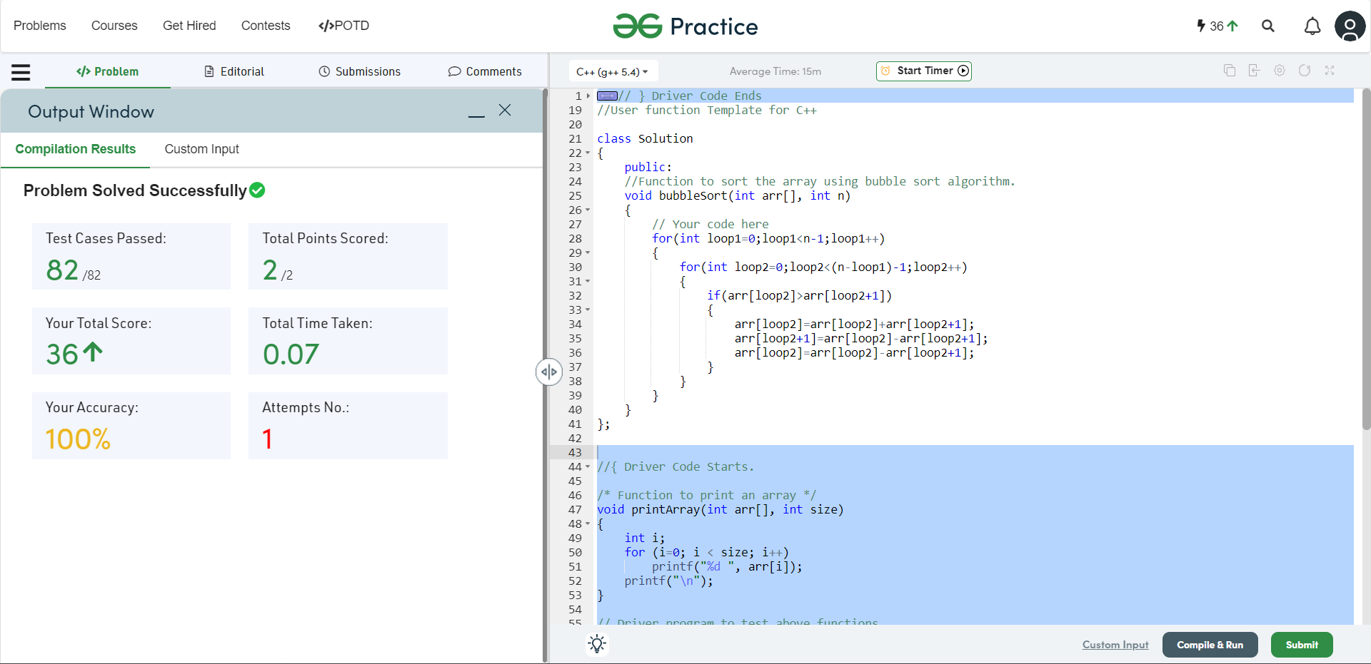

**Understanding about problem:**

In this task I need to Sort the given array using Bubble Sort method.

Note: If you can't understand the problem, feel free to contact us and we'll help you. Please don't copy and paste from anywhere.

ALL THE BEST

Team CP Club